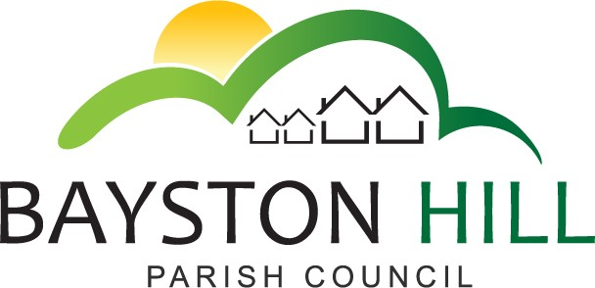

‘protecting and improving the quality of life
for all Bayston Hill residents’

Clerk to the Council/RFO: Caroline Higgins
Chairman: Cllr Mark Underwood
Minutes of the Full Council Meeting held at 7.00 pm on Monday 10 February 2020 in the Memorial Hall.

Present: Cllrs Lewis, (Vice Chair); Hudson; Parkhurst; Clarke; Whittall; Wright; Robinson; Howells; Underwood; and Jones;

In attendance: Caroline Higgins, Clerk; There were no members of the public present.

Cllr Lewis, Vice Chair opened the meeting convened to fill the vacancy in the office of Chairman. The Council debated whether the Vice-Chair’s sabbatical for health reasons had created a vacancy in the office of Vice Chair but it was noted that she had neither resigned nor become disqualified.

143.19/20 ELECTION OF CHAIRMAN – It was proposed by Cllr Parkhurst, seconded by Cllr Whittall and resolved unanimously to elect Cllr Mark Underwood to the office of Chairman until the Annual Council Meeting in May. Cllr Underwood signed a Declaration of Acceptance of Office of Chairman, which was duly witnessed by the Clerk.

144.19/20 TO RECEIVE APOLOGIES AND REASONS FOR ABSENCE – The Council noted Cllr Gouge had sent his apologies.

145.19/20 DECLARATIONS OF INTEREST – None

146.19/20 MIINUTES – The draft minutes of the meeting held on 27 January 2020 together with confidential supplementary notes (pages 37-38) detailing exempt discussions on the staffing budget were reviewed for accuracy.

The Council noted that there had been some discussion as to the Clerk’s pecuniary interest in the consideration of the general staffing budget and it was suggested that a note be added to the minutes for transparency.

The Council discussed amendment to a sub-heading on page 38. The Clerk observed that sub-headings had been added for ease of reference only and could be deleted without affecting the record of the supplementary notes.

After discussing the wording of paragraph 6 on page 38, the Council resolved to defer the approval of the minutes to the next meeting and to seek guidance from SALC as to amendment of draft minutes and supplementary notes; the guidance in Arnold-Baker on Local Council Administration, 10th edition being insufficiently clear.

147.19/20 MEETING SCHEDULE – The Council resolved to bring forward the March Full Council meeting to 16 March 2020. All other suggested meeting dates were agreed as per the schedule circulated with the agenda.

The meeting closed at 7:40pm

