Draft proposal
Shropshire Playing Fields Association

Freedom to Move
Strategy 2019 – 2024

Compiled by David Kilby
M.A Sport, Policy and Community Development, B.A (Hons) Business Enterprise, P.G.C.E (HE)
SPFA Secretary
April 2019

Introduction
Freedom to Move
For too long our towns and villages have been designed around motorised vehicles, leaving them unsafe, unattractive and difficult to navigate on foot or bike. We need protected space; all the way from where you are now to where you want to be.
Only with safe and attractive space will people that don’t walk or cycle now, venture in significant numbers, they need to be able to access fun activities that are exclusive to cycling and walking pathways.
To deliver a cultural change that would bring meaningful benefits to our communities there needs to be massive investment to create new off-road networks of cycle routes that offer safe and fun places to be.
The way we perceive these routes and use these routes needs to change, they should be routes that people need and want to use every day, routes that tap into our innate mechanisms that are as much an essential part of our daily life as breathing and eating, play is one such of these innate mechanism that should be central to our design of these essential routes.
Understanding free play
Play is innate, play is free, play is accessible by all ages and all abilities, play provides fun, play provides health benefits, play helps us to socialise and learn how to integrate with our natural environment, play provides those crucial stepping stones that take us to where we want to be, we must learn and understand how to use it as part of our drive to increase our freedom of movement.
The eight key personality types of play we have identified are; the physical mover; the competitor; the director; the collector; the artist/creator; the storyteller; the joker; the explorer/adventurer

There needs to be major investment over a medium period, an active `play streets fund’ needs to be set up that links all levels of development each working in a collaborative manner to provide this joined up network of `active play streets’ exclusive for cycling and walking.
David Kilby

PART I – Strategic Context

1.1 Influences

There are many influences that the Playing Field Association have had to consider when developing this strategy. This section provides a brief background to some of these influences.

National Context

Government Sport Policy 2016

In December 2015 the Conservative MP and Minister for Sport, Tourism and Heritage Tracey Crouch launched the Governments latest sport strategy report `Sporting Future’: `A New Strategy for an Active Nation’. Reference: (https://www.gov.uk/government/publications/sporting-future-a-new-strategy-for-an-active-nation)

The detail of the-governments strategy demonstrated how it would tackle head on the high levels of inactivity in this country and attempt to redefine what success means, with a new focus on five key outcomes:
- Physical wellbeing -; increase the percentage of the population meeting the Chief Medical Officers guidelines for physical activity.
- Mental wellbeing –; through improved subjective wellbeing
- Individual development –; through increased levels of perceived self-efficacy
- Social and community development -; increased levels of social trust
- Economic development. -; creating jobs, promoting growth and driving exports
The report made it clear that funding decisions would be made in future based on key outcomes that physical activity can deliver in our local communities directing Public Health England and Sport England to explore the best way to include measures of subjective wellbeing, perceived self-efficacy and levels of social trust.

The government stated that it was their ambition that all relevant departments work closer together to create a more physically active nation, where our children and young people enjoy the best play and sporting opportunities available and where people of all ages and backgrounds can enjoy the many benefits that play, sport and physical activity bring, at every stage in their lives.

A Strategy for an Active Nation

To achieve their objectives the government put forward the following proposals:

Children and Young People - Physical literacy
“Opportunities for children to take part in and develop a love of play, sport and physical activity to ensure their long-term enjoyment and participation, to see active children becoming healthy, happy active adults and the talented primary school children of today becoming our role models for the future.”

The government identified that encouraging active play at all ages is important and can help develop healthy habits, enjoyment of physical activity and physical literacy skills, stating that core physical literacy skills provide the common language for all types of participation in play, sport and all types of physical activity.

The report acknowledged that;
“The distinctions between different ball games or between different racquet sports is far less important than developing the skills needed to play those sports later in life. It stated that developing the ABCs of physical literacy through play – agility, balance and coordination – is all important and should be the focus at all ages but particularly the youngest ages”.

Safe active travel
The government strategy acknowledged that there was a need for the Department for Culture, Media and Sport, Department for Transport and Department for Education to work collaboratively with each other and with other agencies to explore how to ensure that all children can learn to ride a bike safely, through the Bike-ability cycle training programme.

It identified that encouraging safe active travel to school through walking or cycling was a key route towards increasing everyday physical activity for school children, parents and carers.

Soft skills for leaders
Notably government put emphasis on the need for leaders to learn how to encourage people to take part in play, sport and physical activity based on fun and enjoyment.

To achieve this, they emphasised the importance of training frontline staff to be able to interact with their customers, with an increased emphasis required focusing on soft skills to build a welcoming and inclusive environment for everyone, regardless of background or ability.

This emphasis corelates with our own beliefs that it is the `overall experience’ that is all important rather than the activity itself and when considering transport the `journey’ rather than the destination becomes an important consideration.

Open Spaces and the countryside
The strategy acknowledges that the UK has some of the best countryside and outdoor space in the world, where people can take part in a wide variety of activities, many of which have not necessarily been supported as much as other more traditional sports.

The strategy says this needs to change in order to provide a variety of different opportunities to engage in physical activity that meets the demand from the customer, rather than telling them what type of activity the provider thinks they should be doing.

“The insight in Getting Active Outdoors showed that ‘being outdoors’ itself is important rather than the sport or activity; it is the environment which is enticing.”

Government want to see the outdoor activities sector thrive and grow as an important alternative way that people can engage in play, sport and physical activity.

“Promoting physical activity is a core part of our strategies to improve the health of the nation. Encouraging inactive people to take up physical activity in any form, ranging from walking, cycling and running to play and sport can have a hugely beneficial effect.”

Broaden Sport England’s role
Therefore, the need is to offer people ways to be physically active that they enjoy, at times and places that suit them, and encouraging people to create opportunities to engage in activity for themselves. The Government say; “creating a more active society is not a choice, it is a necessity when we face an ageing population and a range of health challenges across the life course, including rising obesity amongst children and adults, and the increase in a range of long-term conditions such as diabetes.

Government will broaden Sport England’s role from measuring and supporting sport to measuring and supporting both sport and certain kinds of physical activity, including cycling and walking.

Government are also broadening Sport England’s remit so that it becomes responsible for sport outside school from the age of five, rather than 14. They state a person’s attitude towards sport is often shaped by their experience – or lack of experience – as a child. Many people drop out of sport before they even reach the age of 14, government believe getting Sport England involved earlier will help to combat this.

Local Councils
Government recognises that local councils have an important leadership role to play, bringing schools, voluntary sport clubs, National Governing Bodies of sport (NGBs), health and the private sector together to forge partnerships, unblock barriers to participation and improve the local sport delivery system.

Since the devolution of public health from the National Health Service (NHS) to local authorities in 2013, many types of council have taken the opportunity to integrate physical activity into public health policy as part of a wider shift from a system that treats ill-health to one that promotes wellbeing.

In many areas, local Health and Wellbeing Strategies have highlighted physical inactivity as an issue that needs to be tackled and agreed approaches to tackling it. In places where medical professionals are well-informed about local leisure services and other opportunities to be active and are confident that these will be delivered effectively by suitably trained staff, they are prescribing physical activity.

Government recognises that local authorities have responsibility for wider policy areas which can have a significant impact on the physical activity of the local population, including management of rights of way, parks and other green spaces.

They say:

“being close to where people live, high quality multi-use local green spaces can play a key role as sporting venues and as alternative settings for sport and healthy activity for communities including new audiences that are less likely to use traditional sports centres.

The opportunities to realise the multiple benefits that can be achieved for communities by investing in green spaces and routes as venues for play, sport and healthy activity should be considered whenever they arise, what really matters is how play and sport benefits the public and the country”.

The report also states;
“There is a need to ensure that support for play, sport and physical activity infrastructure is not restricted to pitches, sports halls and buildings. In future, the definition should be drawn more widely, to include all types of places where people take part in activity, including both rural and urban outdoor environments. Providing people with the freedom to use existing facilities and spaces and keeping them in good repair is as important as building new infrastructure.”

National Planning Policy Framework
The report acknowledges that for most people the type, suitability and quality of infrastructure and opportunity to take part have a huge effect on the chances of them trying an outdoor activity for the first time and then coming back to it regularly.

The National Planning Policy Framework recognises the important contribution that opportunities for play, sport and recreation make to the health and wellbeing of communities.

It states; “planning policies should be based on robust and up to date assessments of need. Existing open space, play, sport and recreational buildings and land should not be built on unless the sites have been assessed as surplus to requirements; the loss would be replaced by equivalent or better provision; or the development is for alternative play, sports and recreational provision, the needs for which clearly outweigh the loss.”

The strategy says in future when assessing applications for all major capital investments, Sport England will include a presumption in favour of co-location of services (including health and education) wherever possible.

“New infrastructure will need to accommodate the maximum possible number of activities so that people have the broadest choice of how to be active”.

The report recognises that Playing fields are a vital part of outdoor recreational infrastructure up and down the country and will always remain, therefore Sport England will retain their statutory planning role in respect of the protection of playing fields from development.

Summary
In summary the government has promoted this more positive view of health:
- To improve the health of the population by increasing the length of people’s lives and the number of years people spend free from illness

- The government also acknowledges the range of economic, social and environmental factors that need to consider achieving these aims for health improvement
- To improve the health of the worse off in society and to narrow the health gap.

PART II: Benefits of walking and cycling
A reduction in air pollution, traffic congestion, levels of obesity, are some of the benefits that could be gained from increasing levels of cycling and walking, meanwhile levels of physical inactivity would be reduced which should bring health benefits that would reduce NHS costs.
Aside from these reasons the increased segregation of cycling and walking from motor cars and heavy goods vehicles would drastically reduce the number of fatalities, serious injuries and accidents between the different user groups.
For these reasons, cycling and walking must be given a much higher priority. More people travelling this way will lead to significant benefits for the whole community, even those who to-date have never chose to ride a bike.
To measure future success needs a change of approach with the emphasis being put on the ability of people to move freely, measuring how people access the places they most want to visit, people must be listened to and people’s satisfaction of their communities be considered.
Joined up public transport
Walking and cycling are natural partners to public transport. These combination journeys can reduce people’s reliance on driving. But the aim must be for a seamless integration between differing modes of transport, which means designing transport hubs that are designed to provide opportunities for cyclists and walkers to hop on and off a bus, train or car and be able to continue their journey where a seamless link has been made to the next part of the network.

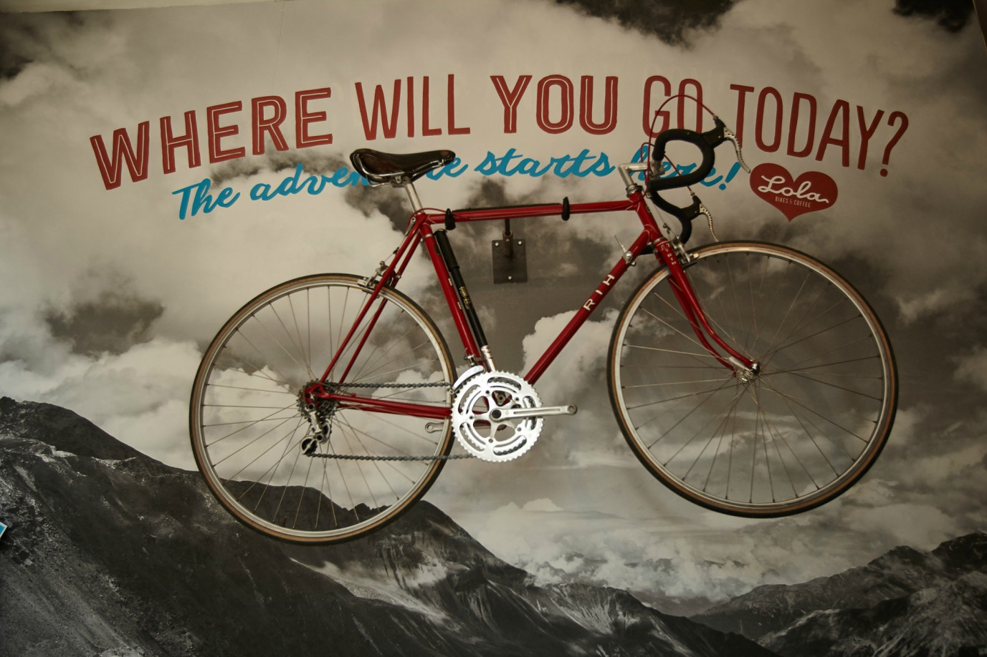
New, better and more innovative design

Cycling routes should be designed to a standard that a competent 11-year-old would choose to use. Safe, low cost opportunities should be provided that encourages everyone to learn to cycle and for everyone to be able to understand the rules of the transport network as well as promote a positive cultural change towards cycling across all communities, including non-cyclists.
Walking and cycling routes need to link smoothly across difficult junctions and be well signposted with walking and cycling times given not just distances.
Street design needs to be of a high quality with surfaces, lighting and security being major considerations, places to rest, take refreshments and toilet breaks along the route are paramount, as well as developing places and activities of interest along the green corridors that lead between cities, towns, smaller market towns and local villages.
A mix of social destinations like shops, sport clubs, pubs, museums, creative areas, are required alongside quiet landscaped areas with gardens and wooded areas to sit and enjoy the tranquillity of the open space.
All need to be planned and designed at the earliest stages and be included in local development plans, local town plans, parish plans and neighbourhood plans.
The avoidance of creating open space power vacuums should be an important consideration as safety and security are paramount in winning user confidence, the understanding of play characteristics will be paramount in achieving all these objectives.
In town centres, filtering traffic, creating protected bike lanes, incorporating trees to screen noise and improve air quality, as well as claiming back public open space from under used parts of roads will be required in order to create places to rest, socialise and play.

Green corridors leading into towns and villages will provide key strategic opportunities to build on this approach, creating safe off-road networks that will allow integrated linkages between towns and villages as well as between villages.

In addition, these new and existing cycle and pedestrian networks need to be distinctively branded and mapped, making them fun and easy to use whether on bike or foot.

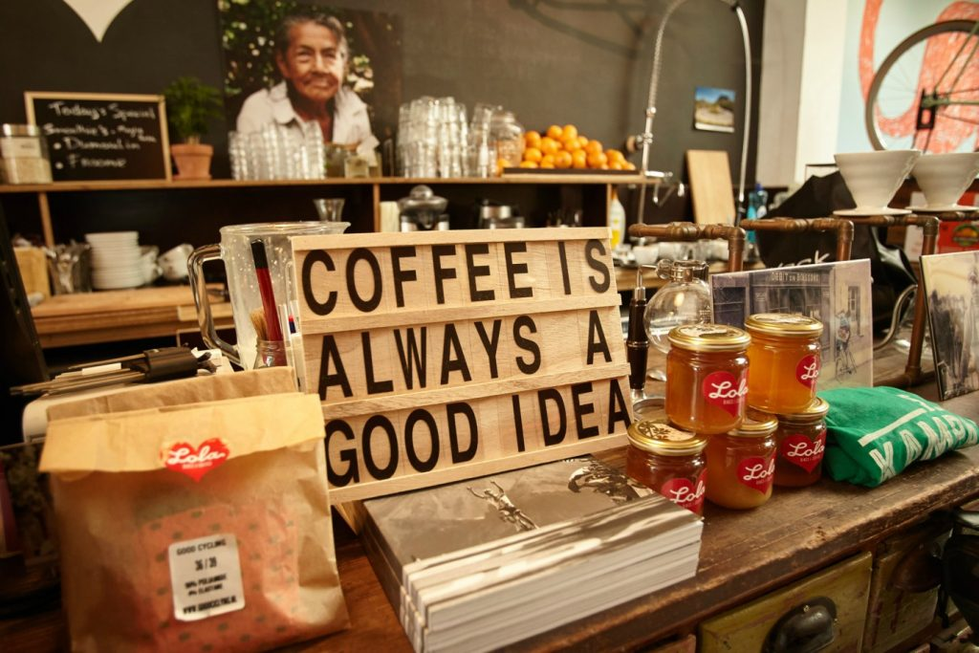

Made to move
Greater Manchester are leading the way with their `made to move’ initiative championed by former Olympic Cyclist Chris Boardman who under the guidance of their then Mayor Andy Burnham became Manchester’s first cycling and walking commissioner.

We acknowledge that part of our vision is based on Manchester’s vision to lead the way in transport across the UK, we hope our interpretation of their campaign does it justice.
Reference: https://www.gmcc.org.uk/2018/02/made-to-move-vision-goal-15-steps/

Safer streets and journeys
Traditionally commuting to work and school have generated the most journeys, we believe change is needed that recognises the importance of how we use our leisure and recreation time.
For this reason we believe more focus and emphasis will be required when planning, to provide not only safe routes to work and school, but also provide safe routes to play, recreation and leisure pursuits, recognising the needs of not only the young person, but the ageing person, the person who has a disability, the parent who has a young child, all of whom require their particular needs to be identified to enable them to access these facilities, affording them greater freedom of choice to move where and when they might want to do so for whatever purpose.
Whilst providing new off-road infrastructure is important, there is also a need to improve existing highways making them safer and more accessible to those on foot or bike. Everyone should be able to walk along well-maintained footpaths to local amenities, with safe suitable crossing points being provided where appropriate, historically junctions where cyclists, pedestrians and motor vehicles converge are where most accidents occur.
A review is needed of all junctions to rate them and improve them in terms of the level of service they provide to all people walking and cycling.
Part III: Safe routes for young people to play

Vibrant communities should offer a variety of places for children to play, places in which children should help shape design by being involved in decision making.

All children and young people should be able to find outdoor places, in or near their homes, where they can play freely and meet their friends and access their interests.

Play supports community cohesion and helps keep children healthy.

Bullying in public places, safety from street crimes, road safety, negative perception of young people and excessive health and safety fears have all contributed to a changing landscape for children`s play.

For that reason, there is a need to continue to champion the rights of children to play, adapting policy to meet the individual needs of all children, an integral part of this right is the child’s ability to have the `freedom to move’ between play sites as and when they choose to do so as individuals.

We believe there is a need for strong and realistic guidelines to be in place that accepts the principle that children are entitled to play safely outdoor both at home and close to their home.

The provision of high quality, well designed and maintained footpaths and cycleways is critical to this being achieved.

Five stage safe routes to play guidelines

- The garden at home – there is a need for all children to have access to outdoor play at home, in their own garden, so they are free to initiate their own play in their own time.

Towards achieving this principle, we advocate that ‘a child`s garden at home` should be their `
castle`, every child`s first right to outdoor space for safe play.

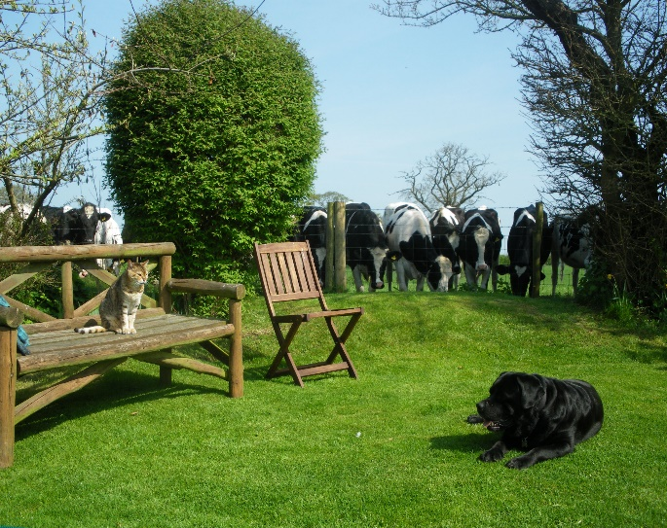m

- Children need to play
- Children need freedom to play
- Children need space to play
- Children need time to play
- Children must feel safe and welcome where they play
- Children need to learn to respect the environment in which they play
- Children should decide what they play
- Children should be able to share play with family, friend’s neighbours and peers.

Action is required that sets minimum standards in new developments for garden space, in which children should have the right to play safely.

Recommended minimum standards
Age range | Minimum size | Characteristics
0 – 3 years | 21 Sq. m | Mixture of grass and hard surface
4 – 8 years | 50 Sq. m | Mixture of grass and hard surface with some semi-permanent play features. (For example, sand pit, goals, playhouse)
9 – 16 Years | 50 Sq. m  (Ideally 10.5m long) | Mixture of grass and hard surface with some semi – permanent play features and natural adventure play features. (for example, tree swing, tree house, dens etc)
- ed for all children to have access to outdoor play at home, in their own garden, so they a
There is a need to promote garden space as being an integral requirement of new developments in order that all children can access outdoor play space in the safety of their home environment.

2. Friends garden – the choice should be available for children to be able to access outdoor play in a friend’s garden, in order to do this, children should be able to move freely and safely in and around their own neighbourhood, by walking or cycling safely between their homes.

Children need to take risks to learn how to manage risks. This is an essential part of growing up, and play is one of the most important ways in which they develop this vital skill.

Concerns about safety are amongst the biggest barriers to outdoor play that children face, this means stepping stones need to be provided to give them the confidence to learn and explore beyond their own home outdoor space.

To do this communities need to work with local partners to reduce the threat of bullying in public places, continue to work with partners to improve safety from crime on streets, improve road safety by way of teaching cycling skills through schemes like `bike-ability`.

Creating `safe routes to play` could involve young people assisting their local communities with the design and planning of new developments, with consideration for street lighting, cycle paths, passageways through estates and traffic speed zones all given due consideration in order to create safer neighbourhoods
r all children to have access to outdoor play at h o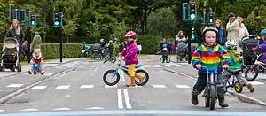

3. Local community play spaces – there is a need for children to be able to access outdoor space for them to play and socialise with friends in their own neighbourhood away from their home environment.

The National Playing Fields Association recommends a minimum standard for outdoor playing space of 2.4 hectares (6 Acres) per 1000 people.

Recognising that outdoor playing space is not the same as public open space. It is space that is safely accessible and available to the public, and of a suitable size and nature for sport, active recreation or children`s play. It is a significant component, but not the only form of open space.

It is important that local planners and communities see the provision of opportunities for children’s outdoor play activities as being different than our more generic use of the word play used earlier in this work, which involves all members of society through our innate ability to use play in all aspects of our lives throughout the entirety of all our lives.

Play it must be remembered is not unique to young children, but is inclusive of everyone throughout their entire lives.

6 Acre Standard – The total standard should be met by ensuring land is available for outdoor sport and children`s play in the following manner.

- Outdoor Sport  1.6 hectares | - Children’s playing space  0.8 hectares
1. Facilities such as pitches, greens, courts, athletic-tracks and a range of sites. | 1. Designated areas for children and young People containing a range of facilities and an environment that has been designed to provide focused opportunities for outdoor play;
2. Facilities described above within the Education sector which are available for Public use by written agreement. | 2. Casual or informal playing space within housing areas.
3 Facilities described above within the voluntary private, industrial and commercial sectors, which serve the leisure time needs for Outdoor recreation of their members or the Public

Minimum Standard - Total playing space = 2.4 hectares
Specific to providing children`s play space are the following guidelines;

 | Time | Walking Distance | Minimum size | Nearest Dwelling | Characteristics
LAP  (Local Area for Play) | 1 Minute | 100m | 100m² | 5m from Activity zone | Small low key games area
LEAP  (Local equipped area for play) | 5 Minutes | 400m | 400m² | 10m from Activity zone | 5 types of play equipment, small games.
NEAP  (Neighbourhood equipped area for play) | 15 Minutes | 1,000m | 1,000m² | 30m from Activity Zone | 8 types of play equipment, opportunities for ball games or wheeled activities

Reference: Fields in Trust Guidance for Outdoor Sport and Play, beyond the 6 acre standard http://www.fieldsintrust.org/Upload/file/guidance/Guidance-for-Outdoor-Sport-and-Play-England-Apr18.pdf
4. School time – there is a need for children to be allowed to access outdoor play during the school day, and where there is an opportunity to extend this opportunity for play on the school site beyond the school day, into weekends and holidays; this should be actively encouraged by policy makers.

There is considerable importance attached to children having play time during the school day when they can unwind and socialise outdoors. Where possible and appropriate PFAs should lobby for minimum `play` times to be scheduled in a child`s school day timetable.

All school sites should offer good play opportunities for children in the form of good well-designed school playgrounds, playing fields and other facilities to support active and constructive play.

Protection of school playing fields and open spaces on school sites should be paramount to our campaign, all local authorities and schools in England need the Secretary of States consent before they can dispose of the whole or any part of a school playing Field. A sale is only allowed if the land is surplus to the needs of the school in question, other local schools and the community. All proceeds must be used to improve sports or education facilities.
5. After school times: Visits to local parks, sports pitches, leisure facilities and recreation grounds are vital to promote healthy lifestyles, children must be allowed the freedom to access these facilities by communities providing safe accessible pedestrian walkways and cycle routes to and from their homes

The school runs
Each morning and afternoon the zones outside the school gates have for the most part become dangerous, congested places where parents drop off their children by car. The opportunity for children to access school safely by bike or foot is essential if this freedom of movement is to gather the momentum that is required for future generations.
To achieve this, as well as making routes safer for children and parents alike, efforts will also be necessary to discourage journeys by car, with both bus and car drop off points being strategically located in places that would increase the need for children to walk to the coach or car pick up points at zones at least 100 metres away from the schools themselves.

Part IV: The Big Town Vision in Shrewsbury

Shrewsbury Big Town Plan Partnership Says:
The town of Shrewsbury is blessed with extraordinary green spaces, courtesy of the River Severn corridor and a superb landscape setting. However, it is a shared opinion by the local community and its stakeholders that Shrewsbury does not make the most of what it has; it needing to make green spaces more accessible, more biodiverse and higher quality in terms of user experience.
In a nutshell we want to make better use of all our public open spaces.
(Reference: https://shrewsburybigtownplan.org/ )
By 2036 it is pictured that Shrewsbury will be a place where traffic in the town centre is very light and slow moving, a place where pedestrians and cyclists can walk and move wherever they want making the streets their own.
It is intended that the big green plan will improve the health and wellbeing of people from the local community by promoting walking, cycling and greater enjoyment of outdoor space, affording greater access to the countryside for those living near to the town centre and greater access to the town centre for those living out of town in the rural environment.
To achieve this the whole town centre and its surrounding areas will need to be accessed more safely by cycle or on foot, avoiding conflict with vehicular traffic. An off-road network of routes between villages, districts and the town centre need to be developed using the route of the river as the main artery on which to map this new emerging network of off-road pedestrian and cycle routes around the area.
Planning tests
The big plan for Shrewsbury has already recommended that a local test should be drawn up before planning consent is given for new developments;
10 goals for Shrewsbury
As part of the big town plan, ten goals were identified that would benefit residents, visitors, traders and workers. We describe four of these goals, that this `Freedom to Move’ document endorses;
These are;
- To make Shrewsbury a better place for the pedestrian and cyclist, especially in the town centre, shifting the balance of priority for movement across the town, from the private car to walking and cycling and greater use of bus and rail.
- To build strong physical and virtual networks connecting education, healthcare, business start-ups, new industries, recreation and sports provision across the town to improve mobility and to form new alliances.
- To make this green town greener still, by connecting existing green spaces across the town, making new links and new parks where possible and making much more of the river corridor. Making strong connections from the town centre through the suburbs and out into the wider countryside in order to improve the health and wellbeing for everyone.
- To raise the quality of design across the town, particularly for new housing.
(Reference: https://shrewsburybigtownplan.org/)
Whilst agreeing with these points as previously stated we strongly endorse that eight play characteristics should be integral to any new transport route design in order to ensure acceptance by those for whom it is intended.
Part V: Four phase approach to actioning our proposals

The town of Shrewsbury is centrally located within the County of Shropshire with a population of approximately 72,000. The town has seen a number of developments in relation to cycling over past years and has potential for more investment to encourage more people to take to two wheels.

In 2008 Shrewsbury was one of the second group of English towns to gain `cycling town’ status. The funding which lasted until 2011, gave birth to `Cycle Shrewsbury’ which aimed to promote cycling through a range of measures including improvements to the cycle network and more cycle training programmes to help more people to cycle to work and schools.

The cycle Shrewsbury project resulted in a 9 per cent increase in cycle journeys between 2009-2011, with the town subsequently receiving a further £4.9 million award from the local sustainability transport fund to allow Shrewsbury to build on this growth trend.

We believe the town of Shrewsbury has the potential to further advance this positive start by implementing some of the new innovative ideas put forward in this report. We recommend a `four’ phase strategic approach to delivery, which we believe with minor adaptations could be applied to not only Shrewsbury, but all market towns and villages across our area.

Phase One Create a Regional Cycling Hub Site: Sundorne Sports Village
We propose that a four phase approach towards change could be implemented starting with phase one, the introduction and identification of a regional cycling hub site at Sundorne Sports Village.
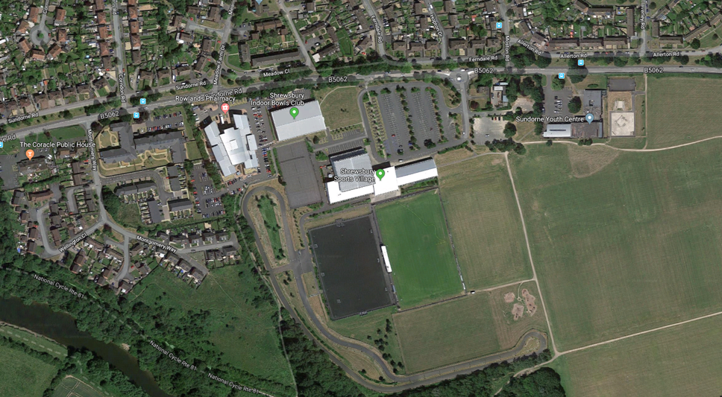
Sundorne Sports Village Shrewsbury
Already established as a base for elite competitive cycling and disability cycling with support from cyclings governing body, we believe this venue should be developed further to meet the cycling needs of a more diverse user group, with young people very much at the heart of our thinking, through the delivery of bikeability programmes, instructor programmes and a whole host of community development programmes led in-house at the Shropshire Community Trust led facility.
Located to the north of Shrewsbury the sports village is situated in a well populated area of deprivation, that has a number of good local car and bus routes leading to and from it, both into Shrewsbury town centre, from the surrounding rural villages as well as to the county wide communities like Telford, Bridgnorth and Whitchurch as well as further a field across the West Midlands.
The site itself provides a massive off-road oppportunity to access through a wooded area, the river severn towpath leading in one direction to the centre of Shrewsbury and in the other towards Haughmond, Uppington, Attingham and beyond to Iron bridge on foot or by bike.
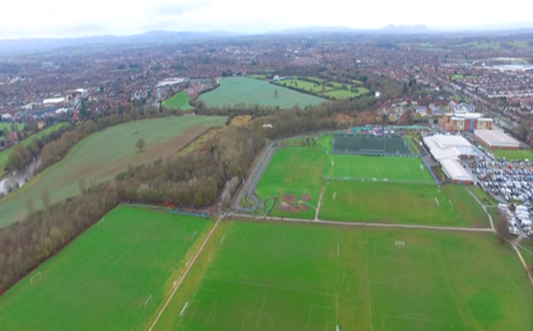
Access to and from grass pitches, through woodland to River Severn tow path

Existing amenities at the Sports Village
- Existing purpose built regional cycle track
- Facilities are staffed 16 hours per day 7 days a week
- Good sized car park facilities with appropriate lighting and CCTV available
- Toilets, changing and shower facilities
- Café and refreshments area
- Large open recreational public space currently used currently predominantly for football.
- Four court fenced hard tarmac area
- Childrens play area
- Trim trail
- Skate park area

Opportunity to make better use of on site public open space areas
Working collaboratively with a wide range of activity user groups including sports like football, we believe an opportunity exists to improve the design of the outside open spaces, putting the needs of cyclists and pedestrians at the heart of all decision making, with the purpose being to utilise the space in a more efficient manner than is happening at present for play, physical activity and sport.
The re-design of the facilities and amenities should also include provision to host medium size outdoor competive and cultural events, accounting for visitor and event organisers needs, including security, safety and access as part of this design process.
Full consultation with all elements of the cycling fraternity would be appropriate as would the formulation of a voluntary working group made up of these interested stakeholders.
Examples of the type of opportunities we believe could be implemented are;
- Transform the current under utilised hard court tennis area, into a high quality toddler, bikeability, truck and cycle fun area.
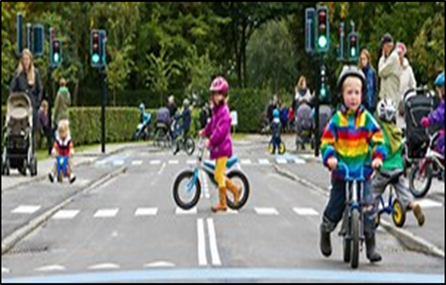
Toddler cycle, trycicle, and truck, fun area.
- Develop and design the woodland area to the south of the site to include an adventure cycle track, with attractive pedestrian access points being provided to the River Severn footpath

Arial view of grass pitches with surrounding woodland leading to the River Severn

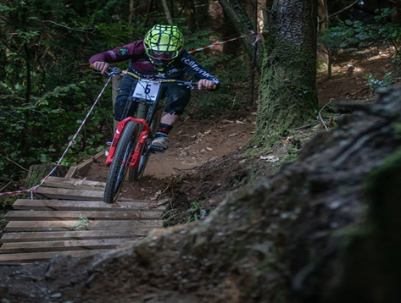
Adventure Cycle track could be designed in Shrewsbury Town Council owned woodland area.
https://youtu.be/MVN4YEenR4Q
- Cycle and pedestrian pathways be provided around the perimeter and between current layout of sport pitches, with appropriate landscaping to create a more inclusive recreational park environment, designed to meet the needs of all key user groups, including recreational dog walkers, families walking and cycling as well as joggers.

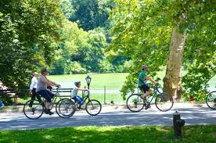

Design should also include opportunities for creating a conducive environment for medium size competive and cultural events with amenities strategically located around the site for this purpose.
- There is a need to up-grade the current cycle track surface and surrounds, to provide high quality competitive regional and national standard facilities and amenities to support large competitive cycle events.

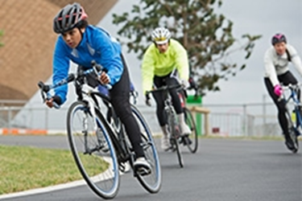

- An opportunity exists to transform the current skate park area to include a BMX track provision alongside the current skate park facilities.
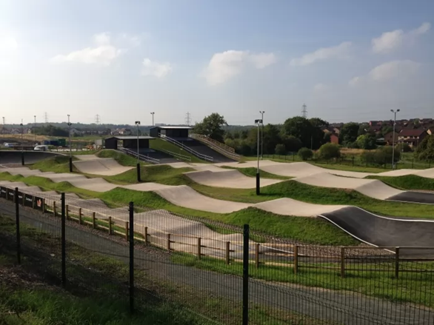

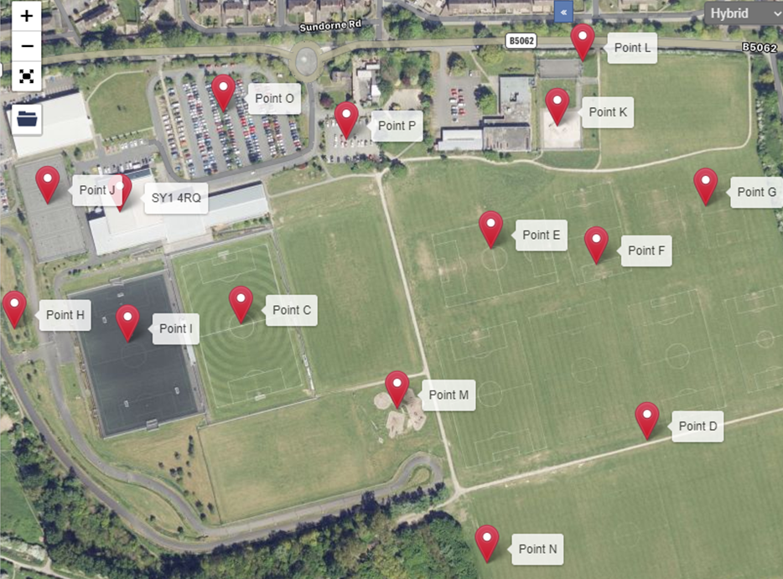
Arial layout plan of Shrewsbury Sports Village
Shrewsbury Sports Village currently has:
- x1 Full Size Senior Grass Competition Pitch, dug outs, and large stand, spectator areas fully enclosed
- x8 Full Size Senior Grass Senior Pitches
- x3 Junior Grass Pitches
- x2 9v9 Grass Pitches – 9v9 1,2
- x2 Mini Grass Pitches – MP 1,2,3
- x1 1Km Floodlit Tarmac Cycle Track
- x1 Full Size Floodlit 3G Astro Turf Pitch, dug outs, Full size goals as well as 3 sets of 7v7 goals, plus full marking for a 11v11 game or x3 7v7 pitches, pitch fully enclosed
- x4 Court Floodlit Tarmac Multi Use Games Area with marking for Netball, Tennis, 5-A-side
- Floodlit Concrete/Tarmac Skate Park
- X1 Court Floodlit Tarmac Recreational Multi Use Games Area, situated next to the skate park
- Play Park
- Wooden Trim track, situated around senior pitch 3-6
- Main Car Parking Areas, Spaces – 293 (Additional 226 available at request at the local medical Centre)
- Over Flow carpark – Spaces – 74
Actions
To achieve this vision there is a need to bring together key stakeholder groups, including schools, public health organizations, cycle clubs and recreational cyclists from the local community, to identify particular needs and also to launch promotional campaigns and events that will change the thinking of those who either live, work or visit Shrewsbury on a regular basis.

Phase 2: Identify main arterial off-road cycle and pedestrian route

Shrewsbury is currently a good place to explore by bike or foot with over 30 miles of cycle routes provided, linking the town Centre with outlying districts in all directions, however most are not traffic free which deters many families from choosing cycling as a recreational past time and indeed as a way of life.

We believe investment in providing a main arterial route from Montford Bridge to the West of Shrewsbury following the route of the River Severn down-stream, past Shelton Rough, the Mount, leading to Frankwell Recreation Ground along the Quarry, past the Greyfriars Bridge near Coleham and then proceeding along the towpath towards the Weir and beyond along Sydney Avenue, provides a great opportunity to make Shrewsbury a truly safe and secure place to cycle, carrying the route on by following the off road path all the way to Sundorne Sports Village and beyond to Haughmond, Upton Magna and then close to Attingham Park at Atcham.

All though some of the off road route is already in place there are problem sections along the route that need to be addressed in order to make the route more attractive to potential new users, in addition some sections of the route needs to be of a higher quality than is there at present, respecting the needs of not only a diverse range of bikes, but also the needs of wheelchair, pushchair users as well as those that use mobility scooters.

We suggest community infrastructure levy funding from the Council and local town and parish council strategic pots be used to fund this project along with other community grants that might from time to time be available. We believe priority should be given towards achieving phase one and two before moving onto phase three, the creation of cycle hub points.

This phased approach should allow appropriate opportunities to engage with key stakeholder groups to map out their route, amenity and facility requirements.

The proposed route
- Montford Bridge to Shelton Rough
- Shelton Rough to the Mount
- The Mount to Frankwell Recreation Ground
- Frankwell Recreation Ground to the Quarry
- The Quarry to the Greyfriars Bridge near Coleham
- The Greyfriars Bridge to the Weir at Sydney Avenue Castlefields
- Sydney Avenue to Sundorne Sports Village
- Sundorne Sports Village to Haughmond/Upton Magna
- Haughmond/ Upton Magna to Attingham Park

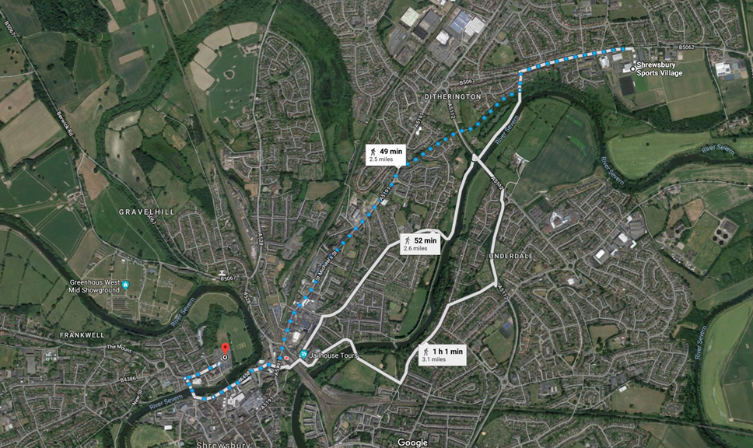
Ariel view of the route following the River Severn

Phase Three; Creation of additional cycle hub, drop-in-stations along the route of the River Severn

Cycle hubs are centres that predominantly cater for cyclists and pedestrians, they need to be conveniently located close to other modes of transport in order to enable smooth links between differing modes of transport, including trains, buses and the car.
There are differing designs but generally hubs should include a premises that has bike hire, bike storage, bike parking, bike maintenance and cleaning space and a recreational area, including a café, toilets, changing and wash facilities They can offer cycle training, events, information on local cycle routes and guided bike rides.
Ideally hubs can provide opportunities for volunteers to be involved in the daily upkeep, monitoring and maintenance of key routes leading to these hubs, as well as a storage area for maintenance equipment.
Along the proposed Shrewsbury off road route identified, we believe there is opportunity for a number of hub facilities to be located at strategic pinch points along the route, affording users the opportunity to leave their cars, store their bikes, clean their bikes, take refreshments, use toilets and wash facilities as well as act as a point of contact for visitor information, guides and general sale of merchandise conducive towards the visitor experience.
The hub sites would need to be managed, maintained and staffed with roles extending to include; security, first aid and general monitoring of the route. The use of CCTV would help facilitate this process and the use of secure gates at appropriate points, to control access to the route in times of high river levels and flooding would be an advantage.
At this embryonic stage of the proposal identification of suitable sites rather than detailed plans would suffice.
Hub site 1: Locate at Montford Bridge near the existing caravan site and Wingfield Arms Pub with access allowed to the hub direct from the main A5 route.

Hub site 2: Shelton Rough; With the proposed development of the North West Relief Road and proposed urban extension, an opportunity may exist to create a hub site as part of the 300 house proposed development alongside the river bank at Shelton Rough.

Hub site 3: Frankwell Recreation Ground (or the newly designed Quarry Swimming Pool)
Located in the heart of Shrewsbury Town Centre the Frankwell Recreation Ground could provide an ideal venue for a second hub site with its easy access into the town centre for users. This would allow changes to be made to the current Cricket pavillion to allow dual use, whilst also making good use of the existing car and coach park, allowing bike users a seamless change from one mode of transport to another, helped by the close proximity of the bus, train and taxi services in the town centre. an added strength of the site being the close proximity of the University and Sixth Form educational facilities with their fast growing student populations.
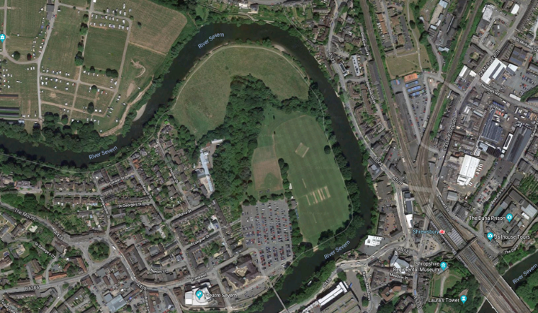
Frankwell Recreation Ground
Hub site 4: Under the railway bridge along the tow path near the Shrewsbury Railway Station on the Castle Walk side of the river. This venue would provide good access for train users to the route as well as providing easy access for users from the Monkmoor, Abbey Foregate, Belle Vue areas of town.
The site would provide an excellent regeneration opportunity which may fit Sport Englands funding criteria on a number of fronts.

Hub site 5: Sundorne Sports Village as previously discussed as part of phase one
Hub site 6: Atcham near Attingham Park and Salop leisure Purpose built stand alone facilities near the entrance to Attingham Park or Salop leisure would be advantageous given the large volume of visitors to both destinations.
Phase four: Create an innovative Enterprise zone along the length of the route.
At the core of this strategy is our understanding the role play has, in shaping our daily lives.
To clarify;
Our understanding of Play is that it is innate, play is free, play is accessible by all ages and all abilities, play provides fun, play provides health benefits, play helps us to socialise and learn how to integrate with our natural environment, play provides those crucial stepping stones that take us to where we want to be.

At this stage of the proposal we believe `play’ can be utilised to support our drive to increase our freedom of movement, to change communities thinking on how they make their journeys whether it be journeys to work, school or as part of our leisure and recreation pursuits.

The eight key personality types of play identified that should be at the core of this process are;
- the physical mover
- the competitor
- the director
- the collector
- the artist/creator
- the storyteller
- the joker
- the explorer
Reference: Stuart Brown Play (1st Edition) Hardcover – 11 Dec 2009

We believe an opportunity exists to design these characteristics into activities and facilities that could be provided along the route of the off-road cycle/pedestrian route outlined.
We believe if the design is such that it taps into the innate play instincts of potential users of the route then it will tap into the repetitive tendencies present in play that will ensure a level of sustainability is guaranteed into the investment of such a route moving forward.

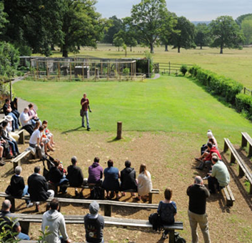 | 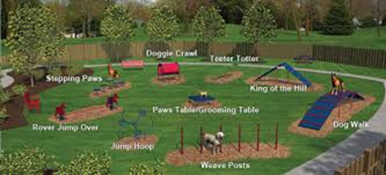 | 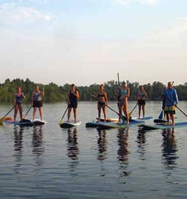
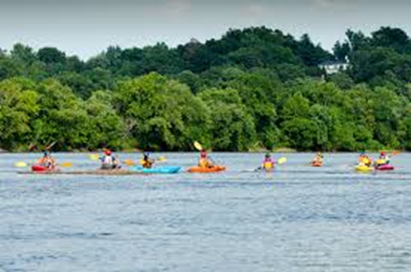 | 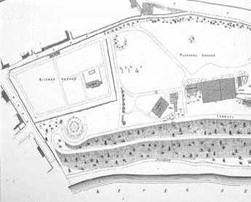 | 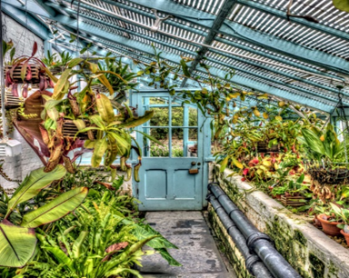

At this stage of the process we have provided a range of images that could relate to the eight personality types of play, they are meant simply to help explain the concept rather than be in any way prescriptive of what will be provided.
We believe market research needs to be fully inclusive of all members of the local communities concerned, so that the design relates very much to their own cultural paradigm, values, and beliefs.
We recognise that the route currently offers a wealth of existing play opportunities, understanding where, why, how and to whom these opportunities exist is critical towards achieving some of the prime aims and outcomes outlined at the start of this report,
these being;
- Physical wellbeing; increase the percentage of the population meeting the Chief Medical Officers guidelines for physical activity.
- Mental wellbeing; through improved subjective wellbeing
- Individual development; through increased levels of perceived self-efficacy
- Social and community development; increased levels of social trust
- Economic development.; creating jobs, promoting growth and driving tourism locally
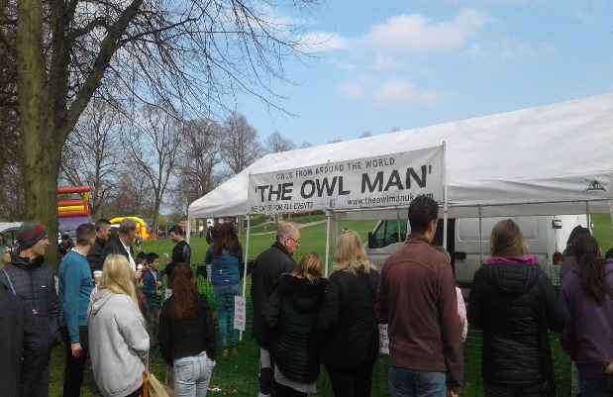 | 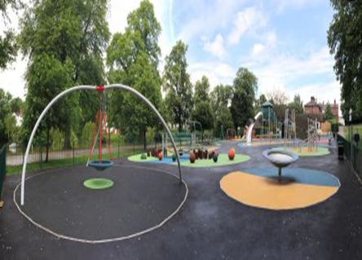
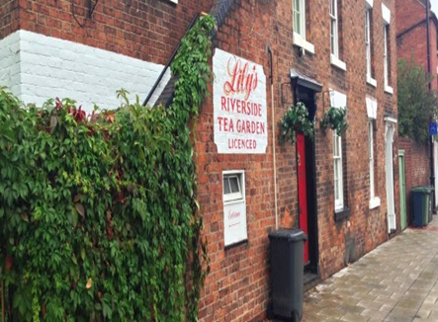 | 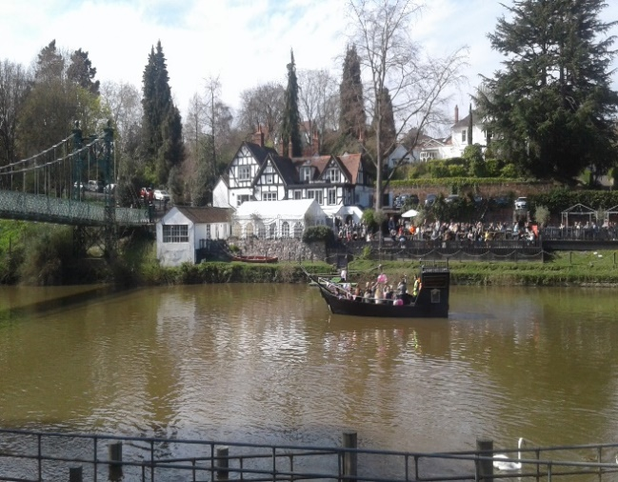
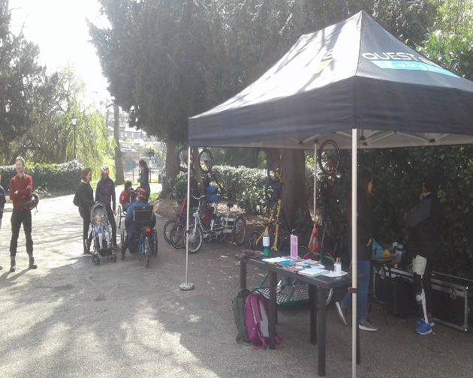 | 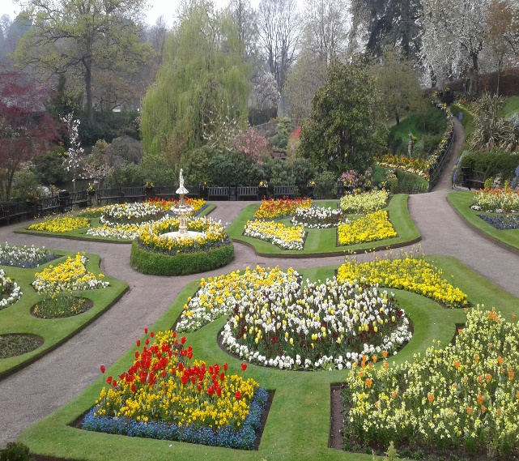
Key references used:
`Sporting Future’: `A New Strategy for an Active Nation’. Reference: (https://www.gov.uk/government/publications/sporting-future-a-new-strategy-for-an-active-nation
Shrewsbury Big town plan: https://shrewsburybigtownplan.org/
Made to Move: https://www.gmcc.org.uk/2018/02/made-to-move-vision-goal-15-steps/

Fields in Trust: Guidance for outdoor sport and play : http://www.fieldsintrust.org/Upload/file/guidance/Guidance-for-Outdoor-Sport-and-Play-England-Apr18.pdf
Stuart Brown Play (1st Edition) 11 Dec 2009: How it shapes the brain, opens the imagination, invigorates the soul.
22nd January 2019
David Kilby

