Bayston Hill NEEDS YOU! | Are you concerned about your local area and the wellbeing of  its residents?  __________  Do you want to take  a civic role & represent your  area and  local people?  __________  Can you contribute  your business or personal skills and expertise for the benefit of the community?  __________  Are you passionate about facilities and maintaining services  for your community?
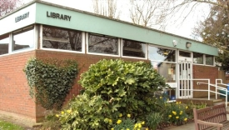

Reductions in Local Government funding are placing at risk services you take for granted. Your Parish Council could step in and fill the void in your community and could benefit from your skills & enthusiasm.

Become a Local Councillor: Make a difference
Elections for Town & Parish Councils will be held
in May 2017

If you would like to make a difference and be involved in shaping the future of the local community, why not stand for election?
Contact your local Council on…
Tel: 01743 874651
Email:baystonhillpc@hotmail.com
Website:
baystonhillparishcouncil.org.uk
… for more information
Produced by Shropshire Association of Local Councils
http://www.alcshropshire.co.uk/elections

