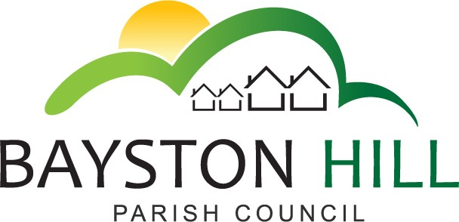
e-mail: clerk@baystonhillparishcouncil.org.uk
Website: www.baystonhillparishcouncil.org.uk/
Tel: 01743 874651
Clerk to the Council/RFO: Caroline Higgins
Chairman: Cllr Mark Underwood

FROM THE CLERK

CORONAVIRUS (COVID-19) RESPONSE – The Parish Council is listening carefully to Government advice and is planning how best to support the community to stay safe and well during the outbreak of Coronavirus. This is a very worrying time and some people will find themselves isolated and with no-one available to support them. As infection levels spread, health and social care services will be stretched and we will need to rely on good neighbours to help each other stay healthy.

At the time of writing the country is in the Delay stage and people are being encouraged to self-isolate if they have been to an affected area and experience any new symptoms of coronavirus. Please remember not to visit your GP surgery if you have mild symptoms of coronavirus but if you cannot manage your symptoms at home you should phone the NHS on 111.

By the time you read this Government advice may well have changed and you are urged to keep up to date with the latest guidance on https://www.nhs.uk/conditions/coronavirus-covid-19/ .

The Parish Council would like to encourage residents to do whatever they safely can to be good neighbours and support people who are self-isolating. Volunteers are reminded of the importance of keeping themselves and their neighbours safe and to leave shopping at the door rather than entering the house. If your neighbour is happy to give you their phone number they may appreciate a regular phone call or chat over the garden fence to reduce loneliness.

The Parish Council recognises that there may be some residents who find themselves without any support from friends or family. If you should find yourself in this situation you can contact the Parish Council on 07458 095619 between 9 – 10am, Monday to Friday and we will try to signpost you to somebody who can help.

DISRUPTION TO COUNCIL SERVICES – (COVID-19) – The Parish Council manages many of the sports and leisure facilities in the village. We are already being advised that grassroots football has been suspended and anticipate further cancelations to sporting activities. As the Parish Office is closing we will not be issuing keys or floodlight tokens until further notice. We apologise for any inconvenience this may cause our regular users.

The Bayston Hill / Lyth Hill 10K may need to be postponed until 5 July but this will be confirmed by email to all registered participants.

The Council will maintain its regular safety checks and emptying of litter bins for as long as possible but it may be necessary to close some Council facilities to protect the public and our staff. The Clerk will work from home for the foreseeable future and contact details will be posted on the website and on the Council door. You can still contact the Clerk by email.

ANNUAL PARISH MEETING – Nominations are still open for the annual Community Awards and nomination forms may be downloaded from the Council website. Certificates will be presented at the Annual Parish Meeting as usual however the meeting will be delayed until Government advice suggests it is safe to hold public gatherings. The new date will be advertised through this page and on our website as soon as the situation improves.

FRIENDS OF BAYSTON HILL LIBRARY – The Library Friends have been busy for weeks, planting, potting and pricking out all kinds of plants for their sale on Saturday 16 May. Different plants will feature this year as well as old favourites. There will be pots of ‘cut flowers for your house’ specialities and our local expert will be there on the day, so if you don’t know your herbaceous from your hellebore, come for advice. Hopefully we will have some cake too!

We are very grateful for the recent gift of metal shelving from an old plastic greenhouse. It is just what we needed, so thank you Mrs D for your kindness.

We are mindful of the possibility that this event may need to be cancelled or postponed and if necessary we will post a notice on the noticeboard outside the library and on Facebook but if we can go ahead safely, we will try to do so.

PARISH COUNCIL MEETINGS - All Council meetings have been cancelled until further notice and the Parish Office closed to visitors with effect from 17 March 2020.

