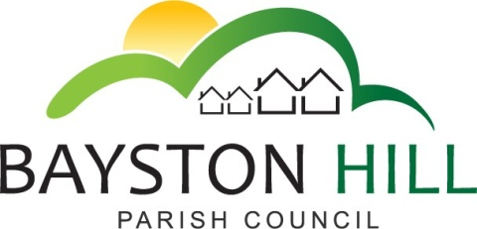

‘protecting and improving the quality of life
for all Bayston Hill residents’

Clerk/RFO to the Council: Caroline Higgins
Chairman: Cllr Fred Jones
Parish Office
Lyth Hill Road
Bayston Hill
Shrewsbury Telephone/Fax: 01743 874651
E-mail: baystonhillpc@hotmail.com
www.shrop.net/baystonhill

Dear Councillor,

You are summoned to attend a meeting of the Full Council on Wednesday 27 July 2016 at 7.30 p.m. in the Memorial Hall.

Caroline Higgins

Caroline Higgins 21 July 2016
Clerk to the Council

A G E N D A

FC83.16 TO RECEIVE APOLOGIES AND REASONS FOR ABSENCE

FC84.16 DISCLOSABLE PECUNIARY INTEREST - Disclosure of any disclosable pecuniary interest in a matter to be discussed at the meeting and which is not included in the register of interests. Members are reminded that they are required to leave the room during the discussion and voting on matters in which they have a disclosable pecuniary interest, whether or not the interest is entered in the register of members’ interests maintained by the Monitoring Officer.

FC85.16 PUBLIC SPEAKING/QUESTIONS AT COUNCIL MEETINGS - To allow members of the public the opportunity to speak on an item listed on the Agenda up to a maximum of 3 minutes.

FC86.16 MINUTES - To approve and sign the minutes of the Full Council meeting held on Monday 20 June 2016

FC87.16 MATTERS ARISING - Any matters arising from the minutes of the Full Council meeting held on Monday 20 June 2016.

FC88.16 CHAIR’S REPORT

FC89.16 CLERK’S REPORT

FC90.16 TO APPROVE AND SIGN ALL PAYMENTS – to follow;

FC91.16 DEVOLUTION OF SERVICES –
- To receive a report from the Clerk on a range of discussions with both Shropshire Council and other Town & Parish Councils, some of which are considering clustering arrangements to share responsibility for local services.
- To consider how and when the community should be consulted on the devolution of services and the likely impact on the Parish Precept.

FC92.16 ADOPTION OF MINUTES FROM COMMITTEES –
- To adopt the minutes and recommendations of the Planning Committee meetings held on 27 June 2016 and 11 July 2016.
- To adopt the minutes of the Amenities Committee meetings held on 21 March 2016 and 6 June 2016.
- To adopt the minutes of the Finance Committee meeting held on 11 April 2016.

FC93.16 OAKLANDS / GLEBELANDS DEVELOPMENT – To consider whether the Parish Council would consider waiving it’s neighbourhood CIL fund in exchange for development of the Community Building as an ‘In-kind’ contribution by a developer.

FC94.16 REVIEW OF STANDING ORDERS

FC95.16 REVIEW OF FINANCIAL STANDING ORDERS

FC96.16 EXCLUSION OF THE PRESS AND PUBLIC - To pass a resolution to exclude the public under Public Bodies (Admission to Meetings) Act 1960 (S1(2)) and in accordance with the provisions of Schedule 12 of the Local Government Act 1972; so as to discuss the following confidential matters.

FC97.16 MINUTES –
- To approve and sign the confidential minutes of the Full Council meeting held on Monday 20 June 2016

FC98.16 MATTERS ARISING – Any matters arising from the confidential minutes of the Full Council meeting held on Monday 20 June 2016.

