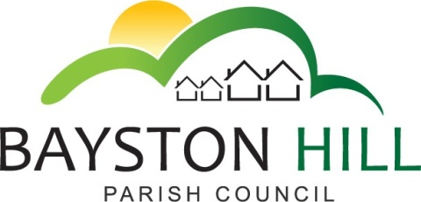

‘protecting and improving the quality of life
for all Bayston Hill residents’

Clerk to the Council/RFO: Caroline Higgins
Chairman: Cllr Fred Jones
Parish Office
Lyth Hill Road
Bayston Hill
Shrewsbury Telephone/Fax: 01743 874651
E-mail: baystonhillpc@hotmail.com
www.shrop.net/baystonhill

Committee Members: Cllrs Clarke (Chairman), Mrs Whittall (Vice Chairman), Cllr Mrs Lewis, Parkhurst, Keel, Gordon and Breeze.

You are summoned to attend an Amenities Committee meeting on Monday 6 June 2016 at 7.30 pm in the Memorial Hall.

Caroline Higgins

Caroline Higgins ` 27 May 2016
Clerk to the Council
AGENDA

A16.16 TO RECEIVE APOLOGIES AND REASONS FOR ABSENCE

A17.16 DECLARATION OF INTEREST - Disclosure of any disclosable pecuniary interest in a matter to be discussed at the meeting and which is not included in the register of interests. Members are reminded that they are required to leave the room during the discussion and voting on matters in which they have a disclosable pecuniary interest, whether or not the interest is entered in the register of members’ interests maintained by the Monitoring Officer.

A18.16 PUBLIC SPEAKING/QUESTIONS AT COUNCIL MEETINGS – To allow members of the public the opportunity to speak on an item listed on the Agenda up to a maximum of 3 minutes.

A19.16 MINUTES - To approve and sign off the minutes of the Amenities Committee meeting held on Monday 21 March 2016.

A20.16 MATTERS ARISING –
- To receive a report from the Clerk on matters arising from the meeting held on 21 March 2016.
- To discuss the future of Long Meadow Toilets (deferred from March meeting – A6.16 d.)
- Play area inspections training – (A6.16 e.) – To note that following a comparison of costs between training in-house staff and using the services of Shropshire Council inspections service it is recommended that a two weekly inspections service be purchased at an annual cost of £550 per site, to include minor routine maintenance of play equipment. (See separate report)

A22.16 PARRS POOL – To consider a proposal from the Shrewsbury Anglers Club to regenerate Parrs Pool and manage it as a fishery. (See separate report).

A23.16 REVIEW OF CHARGES FOR USE OF PARISH AMENITIES – To review and update the schedule of charges for amenity hire with effect from 1 July 2016 (see separate schedule of proposed rates)

A24.16 WEED SPRAYING – To authorise suitably qualified Council staff to undertake ‘top up’ weed spraying on Parish land, where required, (in addition to ongoing annual weed spraying contract)

A25.16 ONGOING PROJECTS – To review ongoing projects.
- Long Meadow Play Park
- The Common
- Sensory Gardens
- Planters on The Parade

A26.16 CORRESPONDENCE – To review and discuss any letters received that relate to Amenities.

A27.16 PAYMENTS – To approve and sign all payments

A28.16 EXCLUSION OF THE PRESS AND PUBLIC - To pass resolution to exclude the public under Public Bodies (Admission to Meetings) Act 1960, so as to discuss the following confidential matters.

A29.16 CONFIDENTIAL MINUTES – To approve and sign off the Confidential Minutes of the Amenities Committee meeting held on Monday 21 March 2016

A30.16 MATTERS ARISING - To consider any matters arising from the confidential minutes of the Amenities Committee meeting held on Monday 21 March 2016

