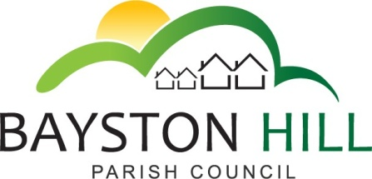

‘protecting and improving the quality of life
for all Bayston Hill residents’

Clerk to the Council/RFO: Caroline Higgins
Chairman: Cllr Fred Jones

Committee Members: Cllr Jones (Chairman), Cllr Keel (Vice-Chairman), Cllr Clarke (Amenities), Cllr Parkhurst (Finance) and Cllr Mrs Lewis (Planning).

You are summoned to attend a meeting of the Personnel Committee on Monday 20 March 2017 at 6:00 pm at the Parish Office

Caroline Higgins

Caroline Higgins
Clerk/ RFO 13 March 2017

AGENDA (Publishable Summary)

P1.17 EXCLUSION OF THE PRESS AND PUBLIC - To pass a resolution to exclude the public under Public Bodies (Admission to Meetings) Act 1960,ss 1(2), so as to discuss the following confidential matters.

P2.17 TO RECEIVE APOLOGIES AND REASONS FOR ABSENCE

P3.17 DECLARATION OF INTEREST

P4.17 MINUTES – To approve and sign off the minutes of the meeting held on Monday 12 December 2016

P5.17 REVIEW OF HANDYPERSONS’ HOURS

P6.17 STAFF CONTRACTS

P7.17 PENSIONS DISCRETIONS POLICY

P8.17 HR SUPPORT PACKAGE

P9.17 CONFIRMATION OF SALARY SCALES; PENSION CONTRIBUTION BANDS AND RATES 2017/18

P10.17 CONFIRMATION OF SALARY SCALES; CONTINUOUS SERVICE AND HOLIDAY ALLOWANCES FOR ALL STAFF – 2017/18

