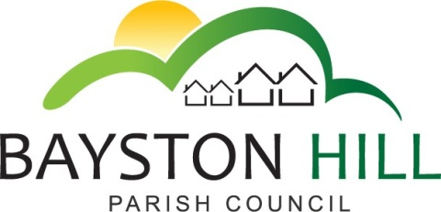

‘protecting and improving the quality of life
for all Bayston Hill residents’

Clerk to the Council/RFO: Caroline Higgins
Chairman: Cllr Fred Jones
Parish Office
Lyth Hill Road
Bayston Hill
Shrewsbury Telephone/Fax: 01743 874651
E-mail: baystonhillpc@hotmail.com
www.baystonhillparishcouncil.org.uk/

Committee Members: Cllrs Clarke (Chairman), Mrs Whittall (Vice Chairman), Cllr Mrs Lewis, Parkhurst, Keel and Breeze.

You are summoned to attend an Amenities Committee meeting on Monday 6 February 2017 at 7.30 pm in the Memorial Hall.

Caroline Higgins

Caroline Higgins ` 30 January 2017
Clerk to the Council
AGENDA

A1.17 TO RECEIVE APOLOGIES AND REASONS FOR ABSENCE

A64.16 DECLARATION OF INTEREST - Disclosure of any disclosable pecuniary interest in a matter to be discussed at the meeting and which is not included in the register of interests. Members are reminded that they are required to leave the room during the discussion and voting on matters in which they have a disclosable pecuniary interest, whether or not the interest is entered in the register of members’ interests maintained by the Monitoring Officer.

A2.17 PUBLIC SPEAKING/QUESTIONS AT COUNCIL MEETINGS – To allow members of the public the opportunity to speak on an item listed on the Agenda up to a maximum of 3 minutes.

A3.17 MINUTES - To approve the minutes of the joint meeting with the Finance Committee held on 14 November 2016.

A4.17 MATTERS ARISING – To consider matters arising from previous Amenities Committee meetings, the joint meeting with the Finance Committee held on 14 November and the Amenities Matters agreed at the Full Council Meeting held on 12 December 2016, not arising elsewhere on the agenda; . (Action list to follow)

5.17 CLERK’S REPORT - To note expenditure on revenue items under £500, approved in accordance with Financial Regulation 4.1

A6.17 PARRS POOL – To review phase 1 of the regeneration project and approve release of the remaining retention (5%); To discuss the removal of fallen tree and to set a suitable budget, (phase 2); To receive a recommendation that a planting scheme be developed in the spring to enhance the appearance of the pool and to approve a suitable budget for planting, (phase 3).

A7.17 PLAY AREA INSPECTIONS – To receive a report on recent staff changes at Shropshire Council and review the inspections regime.

A8.17 COMMUNITY FACILITIES REVIEW – To receive feedback from Cllrs Candy and Keel on the recent Energize Conference and progress towards an application for grant funding to improve the changing facilities at Lythwood Pavilion.

A9.17 TREES AT LYTHWOOD PAVILION – To consider a request from a neighbour to reduce the height of the trees in the pavilion area.

A10.17 ASSET RENEWALS – To review the condition of parish assets and identify any repairs or replacements that may be required. (See minute J10.16.2)

A11.17 ONGOING PROJECTS – To review ongoing projects.

A12.17 CORRESPONDENCE – To review and discuss any letters received that relate to Amenities.

A13.17 PAYMENTS – To approve and sign all payments

A14.17 EXCLUSION OF THE PRESS AND PUBLIC - To pass resolution to exclude the public under Public Bodies (Admission to Meetings) Act 1960, so as to discuss the following confidential matters.

A15.17 CONFIDENTIAL MINUTES – None

A16.17 AMENITIES HIRE –To approve a discounted rate for the regular booking of the Youth and Community Building, in line with those approved for sporting facilities

A17.17 CONFIDENTIAL QUOTATIONS – To consider confidential quotations relating to ongoing projects

