TABLE TOP SALE

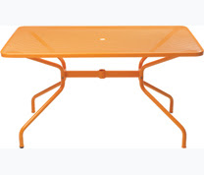

Saturday 8 April 2017
10am - 1pm

at Bayston Hill Methodist Centre
(Lansdowne Road, Bayston Hill)

Free car park Refreshments available

Tables £5.00 (cash) each. Please book your table by telephoning Chris on 01743 871151

All funds raised will be donated to Bayston Hill Library
- If you are interested in supporting the Friends of Bayston Hill Library please come along, buy a cuppa, and talk to us!

