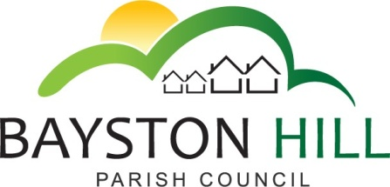protecting and improving the quality of life
for all Bayston Hill residents’

Clerk to the Council/RFO: Caroline Higgins
Chairman: Cllr Keith Keel

You are invited to attend a drop-in event on Monday 5th March 2018
at the Memorial Hall, 6 - 7pm
To suggest where to put
Adult Fitness equipment.
This is your opportunity to have your say on the Parish Council’s decision to purchase Equipment for the wellbeing of the community.

Your Money, Your Views; why not have your say?

