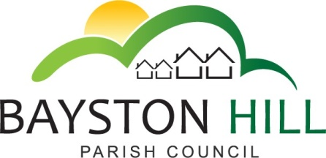
Defibrillator Training
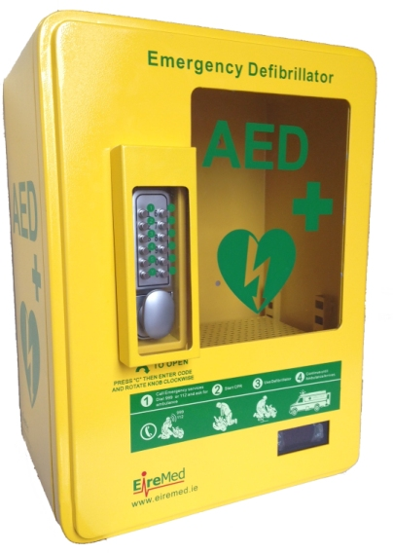
FREE Training Sessions in the use of the public access defibrillator outside the Beeches Medical Practice have been arranged on the dates below. To book a place please contact Caroline Higgins (Parish Clerk) on 01743 874651 or email baystonhillpc@hotmail.com. Alternatively, call into the Parish Office for more information
Training Sessions:
22 February 2017 10am – 1pm
4 April 2017 12 – 3pm
11 April 2017 6:30–9:30pm

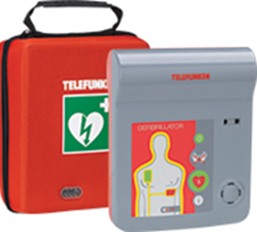

“A defibrillator is a device that gives a high energy electric shock to the heart through the chest wall to someone who is in cardiac arrest.
This high energy shock is called defibrillation and it’s an essential life-saving step in the chain of survival. If you come across someone who has had a cardiac arrest, it’s vital to call 999 and start CPR. Then you should find out if there is a defibrillator nearby”. (British Heart Foundation)

