Mr Saple Name  
12 Sample Road  
Sampetown

Sampleshire

AB12 3CD



**Project title:**   
Bayston Hill, Glebe Road, Shrewsbury.

**Project ref:** 6124876

**March 2017.**

Contractor logo

Dear Customer,

**We’re making**

**improvements**

**that may affect you**

………………………………………………………………………………………………………………………….

* **We will be carrying out some works on the water main on Glebe Road, Bayston Hill SY3 0PJ**
* **Your water supply may be temporarily interrupted at some point during this work**
* **Work will start week commencing Monday 24 April 2017.**
* **Work is expected to last approximately six to seven weeks.**

………………………………………………………………………………………………………………………….

Why are we doing this work?

Our pipes have been servicing your local community for many years and to make sure it stays that way we are investing to renew parts of the old water pipe; this work will ensure that our customers can continue to enjoy a reliable supply of water.

**When is the work taking place?**

This work will start week commencing Monday 24 April 2017 for approximately six to seven weeks.

**Where is the work taking place?**

* We plan to carry out work on the water mains along sections of Glebe Road, Lythwood Road, and Yew Tree Drive
* This work will take place from outside house number 35c at the junction of Beeches Road, working in approximately 100 - 200 metre sections along Glebe Road to the Junction of Lytham Road from 24/04/17, this will be undertaken using a road closure, during this section of works we will also be carrying out some water main renewal work on Yew Tree Drive this will take place from outside house number 2, to outside house number 14 this section of work will also be undertaken using a road closure, the final stage of this work will be on the junction of Glebe Road and Lythwood Road this section will be undertaken using three way traffic lights. (please see diagram on rear for approximate working locations).

**What we will do to keep the disruption to a minimum**

We understand that road works can be inconvenient for local residents, which is why we will be taking the following steps to make sure we cause minimum disruption:

* Our contractors, Amey, will complete this work on our behalf, to carry out this work effectively and safely it will be necessary to complete this work using road closures and three way traffic lights
* When a section of road is closed we’ll keep restricted access to resident’s properties and local businesses to a minimum.
* We aim to complete the works within the time frame we have stated above, but will try to finish before this date.
* Traffic management always causes some delays, especially at peak times. We will work hard to reduce interruption to traffic in the morning and evenings, however we would advise that you allow more time for your journeys.
* There maybe a time that we require to have a disconnection of the water mains supply, we aim to give prior notice of 48hrs in advance of any planned interruptions.

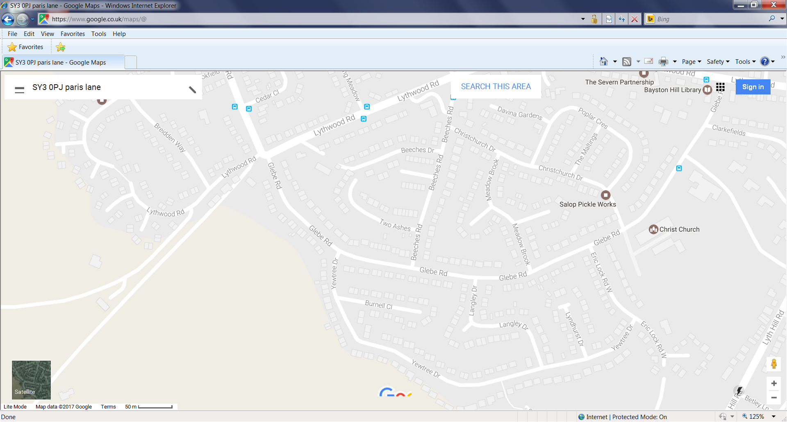

Key.

Road Closure

Traffic lights

Lythwood Road junction

**Work starts:** 22/05/17

**Duration** 1-2 weeks

**Three way traffic lights**

Yew Tree Drive

**Work starts:** 01/05/17

**Duration on this section:** 1-2 weeks

**Road Closure**

Glebe Road

**Work Starts here:** 24/04/17

**Duration:** 6-7 weeks

**Road Closure**

**Will we get the work completed within the time scales we state?**

In our experience, because many of the water mains have been underground for a number of years, when we start to do the work we can sometimes come across problems that can cause the job to last longer. If there are any changes to the works we will communicate this to you as soon as possible.

**Retail Businesses**

If you own or operate a business which receives visiting customers who purchase goods of services from you and our works are affecting your sales income. Then please contact our Business Compensation Manager [**businesscompensation@severntrent.co.uk**](mailto:businesscompensation@severntrent.co.uk)for further advice.

**Have you got a question for us?**

If you would like to know more you are welcome to come and see us at our public exhibition on **Thursday 30 March 2017** in **Christ Church Hall, Glebe Road SY3 0PZ,** between **4pm-7pm** where our team will answer any questions you may have.

**Keeping you up to date on the move**

By texting **GLEBE** to **01952 780333** you can register for free text alerts about our improvement works for the planned water pipe renewal works in your area.

**Who do I contact about these works?**

Our contract partner, Amey, will be carrying out the work on our behalf and you can contact them during normal office hours on the numbers shown here:

Call Centre Amey 24hrs Call Centre 0800 521660

John Coventry Amey Customer Service 07827826688

If your call is about your water supply or sewerage service, you can call our Customer Operations Service Centre on 0800 783 4444.

Yours sincerely,

**Severn Trent Water**