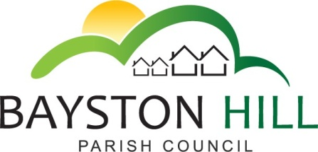

‘protecting and improving the quality of life
for all Bayston Hill residents’

Clerk to the Council/RFO: Caroline Higgins
Chairman: Cllr Fred Jones
22 March 2017

Actions list – Amenities Meetings:

Minute number: | Action: | Action by: | Date for completion: | Status: (Completed; ongoing or outstanding
A54.16 Brookfield Waste Bin | Write to residents of Brookfield re bin position; monitor weekly bin collection by Shropshire Council | Clerk |  | Ongoing – further approach by Brookfield residents requesting a covered bin be placed alongside the open litter bin. (Agenda item A54.16)
A55.16 a  Long Meadow Play Area  A8.17  A12.17 | Keep access clear sign; letter to school  Routine inspections review  Wet-pour shrinkage & toddler gate | Clerk | March meeting | Email to school complete.  Sign outstanding  Inspections review complete  After discussing wet pour with SC inspector it is no longer regarded as pressing – suggest monitor shrinkage and adjust gate internally
A55 16 b  Defibrillator | Arrange MOU with Ambulance service;  Arrange training | Clerk | ASAP | Cabinet installed;  MOU agreed Training ongoing
A55.16 c  The Common | Replacement boulders | Cllr Clarke | ASAP | Outstanding
A5.17 | Year-round planter for outside Lyth Hill Stores | Clerk | ASAP | Agenda item A30.17
A6.17 | Recover horse trough from farmer Davies  Tree on cable in Community woodland | Clerk | March | Ongoing - arranging delivery to pavilion  Completed
FC161.16 1.  Replacement of Cylinder Gang Mower | Sell redundant gang mowers | Clerk/ Cllr Clarke | Spring | Ongoing
FC161.16.3. Long Meadow Maze | Seek 3 quotes and arrange work | Clerk & Cllr Clarke | End of March | Complete
A7.17 | Parrs Pool – Obtain planting scheme; negotiate price for phases 2 & 3;  Consider additional seating | Clerk | March meeting | Ongoing - Agenda item A24.17
A9.17 Review of Parish Facilities | Prepare funding bid to improve facilities;  Undertake questionnaire;  Arrange feasibility study;  Online booking facility  Review terms of hire | Cllrs Candy and Keel in conjunction with the Clerk | January / February 2017  March meeting | Ongoing  Ongoing – agenda item A26.17  Ongoing A26.17  Agenda items A25.17 i) and ii)  Ongoing – Agenda items A25.17 iii) & iv)

