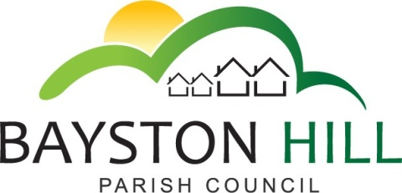

‘protecting and improving the quality of life
for all Bayston Hill residents’

Clerk to the Council/RFO: Caroline Higgins
Chairman: Cllr Keith Keel
Parish Office
Lyth Hill Road
Bayston Hill
Shrewsbury Telephone/Fax: 01743 874651
E-mail: baystonhillpc@hotmail.com
www.baystonhillparishcouncil.org.uk/

Committee Members: Cllrs Breeze (Chairman), Mrs Clode, Jones, Keel; Mrs Lewis; Gouge; Hudson.

You are summoned to attend a Planning Committee meeting on Monday 14 January 2019 at 6:30pm in the Memorial Hall.

Caroline Higgins

Caroline Higgins
Clerk to the Council
7 January 2019
AGENDA

P80.18/19 TO RECEIVE APOLOGIES AND REASONS FOR ABSENCE - Cllr Lewis

P81.18/19 DISCLOSURE OF PECUNIARY INTEREST – Disclosure of any disclosable pecuniary interest in a matter to be discussed at the meeting and which is not included in the register of interests. Members are reminded that they are required to leave the room during the discussion and voting on matters in which they have a disclosable pecuniary interest, whether or not the interest is entered in the register of members’ interests maintained by the Monitoring Officer.

P82.18/19 PUBLIC SPEAKING AT COUNCIL MEETINGS – To allow members of the public to speak on any planning related item for a maximum of 3 minutes each at the Chairman’s discretion

P83.18/19 MINUTES - To approve and sign off the minutes of the Planning Committee meeting held on Monday 17 December 2018.

P84.18/19 MATTERS ARISING – If any

P85.18/19 PLANNING APPLICATIONS – To consider the following planning applications:

- To consider any planning applications validated since the publication of the agenda

P86.18/19 PLANNING DECISIONS – To note the following Planning Decisions:

- 18/05250/FUL - 90 Yewtree Drive, Bayston Hill, Shrewsbury, Shropshire, SY3 0PY - Erection of part single part two storey rear extension; alterations to porch and replace bow window with flush window – Decision Grant Permission

- To note any planning decisions made since the publication of the agenda

P87.18/19 PLANNING APPEALS – To consider any planning appeals registered since the publication of the agenda.

P88.18/19 CORRESPONDENCE – To note an update on CIL Local funding support from Shropshire Council (14 December 2018) and consultation with Parish Councils during spring 2019 on proposed changes to the process; To note that a deadline of 15 February 2019 has been set for Expressions of Interest for CIL Local funding.

To note an email from a resident analysing the evidence for the Local Development Plan Review (Mr JH – 3 January 2019)

P89.18/19 LOCAL PLAN REVIEW – To agree a response to Shropshire Council’s Draft Local Plan Review with reference to the numbers of dwellings proposed in Bayston Hill; the redrawing of the development boundary and the assessment of each site identified, including those supported and those rejected by Shropshire Council.

