60.18/19 GOAL POST REPLACEMENT
During annual cleaning and repainting of the goal posts the upright posts from pitch 2 were found to be rusted through where they were inserted into the sockets, (see pictures).
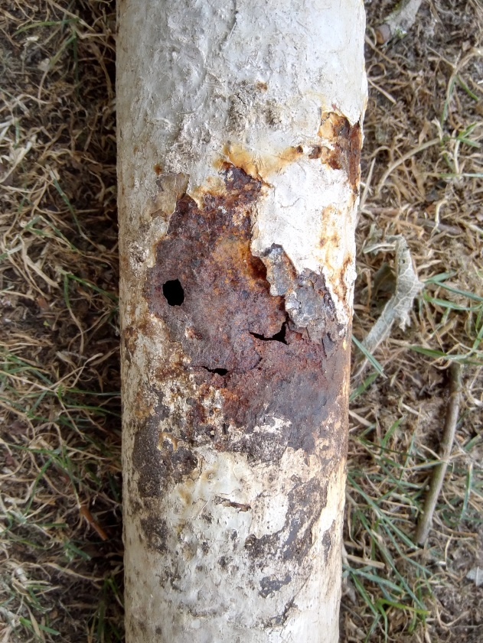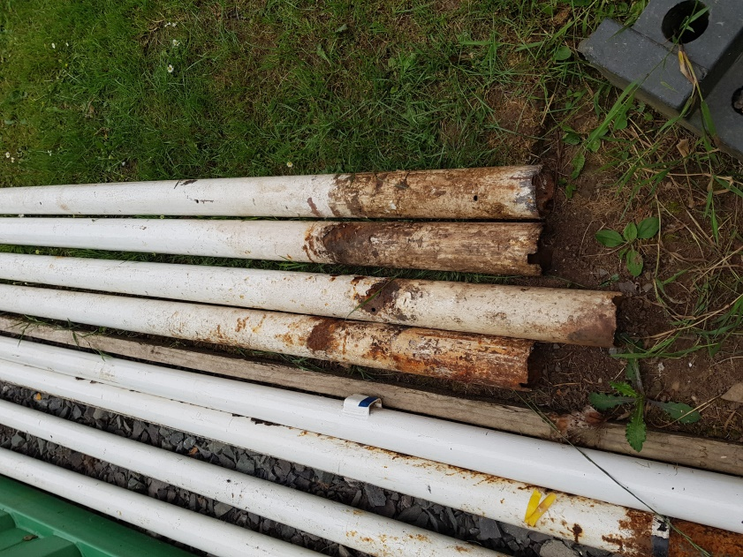
It would be dangerous to re-use these posts and there are no alternative posts available of this size to replace them so it is recommended that this set of goal posts be replaced with equivalent new posts.
The posts are super-heavyweight steel football goals made from 76mm diameter x 3mm thick steel.
Prices for like for like posts are detailed under Confidential Quotations. Posts are sold as a pair with a set of new sockets but as new sockets were installed last August these could be kept for future use, (possibly in case there is a need to re-position the pitch).
Although lighter weight posts are slightly cheaper, the posts are 60mm diameter so would not fit the existing sockets. Any saving made by purchasing lighter weight goals would therefore be offset by the cost of installing new sockets.
There are slight variations in the design of net supports from the various suppliers so it would be sensible to purchase new hangers with the goals to ensure compatibility. The existing net supports do not conform to the current safety specifications due to the possibility of head entrapment, but could be kept as spares for the other pitches. The nets we have are adequate but where posts are sold as a pack it can be more economical to buy them with hangers and nets included. There is a choice of solid steel or tubular steel hangers. Solid steel are more robust.

