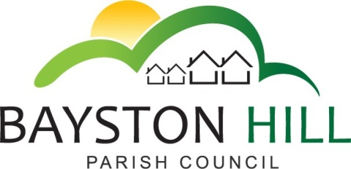
3.17

‘protecting and improving the quality of life
for all Bayston Hill residents’

Clerk to the Council/RFO: Caroline Higgins
Chairman: Cllr Keith Keel
Parish Office
Lyth Hill Road
Bayston Hill
Shrewsbury Telephone/Fax: 01743 874651
E-mail: baystonhillpc@hotmail.com
www.baystonhillparishcouncil.org.uk/

Committee Members: Cllrs Clarke (Chairman), Mrs Whittall (Vice Chairman), Cllr Mrs Lewis, Parkhurst, Keel, Breeze and Mrs Howells.

You are summoned to attend an Amenities Committee meeting on Monday 9 April 2018 to follow the Planning Committee meeting commencing at 6.30 pm in the Memorial Hall. The Amenities Committee meeting will start no earlier than 7:00pm

Caroline Higgins

Caroline Higgins ` 29 March 2018
Clerk to the Council
AGENDA

A20.18 TO RECEIVE APOLOGIES AND REASONS FOR ABSENCE

A21.18 DECLARATION OF INTEREST - Disclosure of any disclosable pecuniary interest in a matter to be discussed at the meeting and which is not included in the register of interests. Members are reminded that they are required to leave the room during the discussion and voting on matters in which they have a disclosable pecuniary interest, whether or not the interest is entered in the register of members’ interests maintained by the Monitoring Officer.

A22.18 PUBLIC SPEAKING/QUESTIONS AT COUNCIL MEETINGS – To allow members of the public the opportunity to speak on an item listed on the Agenda up to a maximum of 3 minutes.

A23.18 MINUTES - To approve the minutes of the Amenities Committee meeting held on 5 February 2018.

A24.18 USE OF PARISH FACILITIES – To consider the following requests to utilise parish council facilities:

- Buggy Fitness Class – See attached report
- Hire of Youth and Community Building by Christ Church Nursery (report to follow)
- Walking Football

A25.18 OUTDOOR GYM EQUIPMENT – To consider the siting of gym equipment and selection of suitable equipment;

A26.18 GRASS CUTTING CONTRACT – To select a contractor to cut grass at the Common, the Glebefield and the A49 verges.

A27.18 WEED CONTROL CONTRACT – To select a contractor to undertake weed spraying on Parish property (3 year contract)

A28.18 CHANGING ROOM IMPROVEMENTS – To consider the response from the Football Federation to the grant application (Report to follow)

A29.18 CLERK’S REPORT, including MATTERS ARISING – To note progress on matters arising from previous Amenities Committee meetings, not arising elsewhere on the agenda, (see action list). To note any other points of information not requiring a decision.

A30.18 REVIEW OF PARISH AMENITIES – To identify any matters requiring action at any of the Council’s amenities not covered elsewhere in the agenda:
- Longmeadow Playground
- Lythwood sports complex
  - Pavilion building and compound
  - Football pitches
  - Astro turf
  - Tennis court
  - Bowling green
  - Skate park
  - BMX track
  - MUGA
- Community woodland and sensory garden
- Parrs Pool and woodland
- The Common
- The Glebefield
- Youth and Community Building

A31.18 PAYMENTS – To approve and sign all payments (List to follow)

A32.18 EXCLUSION OF THE PRESS AND PUBLIC - To pass resolution to exclude the public under Public Bodies (Admission to Meetings) Act 1960, so as to discuss the following confidential matters

A33.18 CONFIDENTIAL QUOTATIONS

